Boyd Band Registration and Payment Process for Freshman/New Members
Step 1: Register If you already have an account with another organization that uses Membership Toolkit you can use the same email and password.
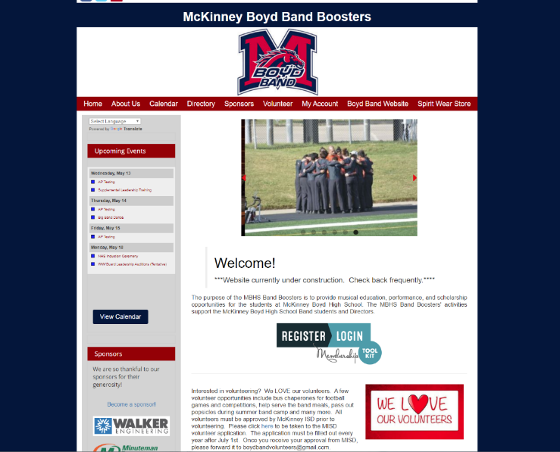
Step 2: Create an Account
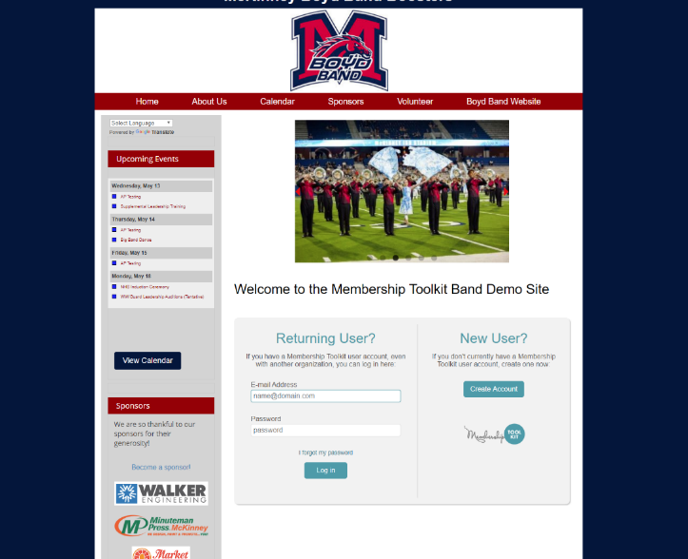
Step 3: Complete the form and click “Verify My Email.”
Membership Toolkit will send you an email
Click the link in the email message to verify your email address and complete the process. The link expires in 2 hours. If you do not receive the email, check your spam or junk folders.
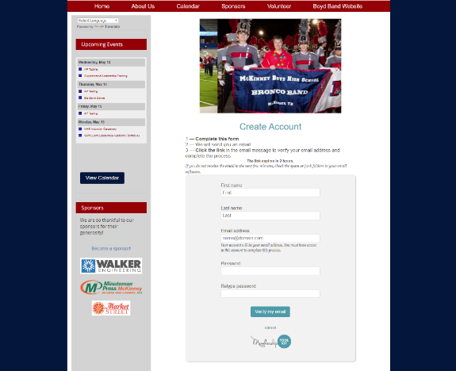

Step 4: Log In Once you have verified your email address, log back in and select parent and student information.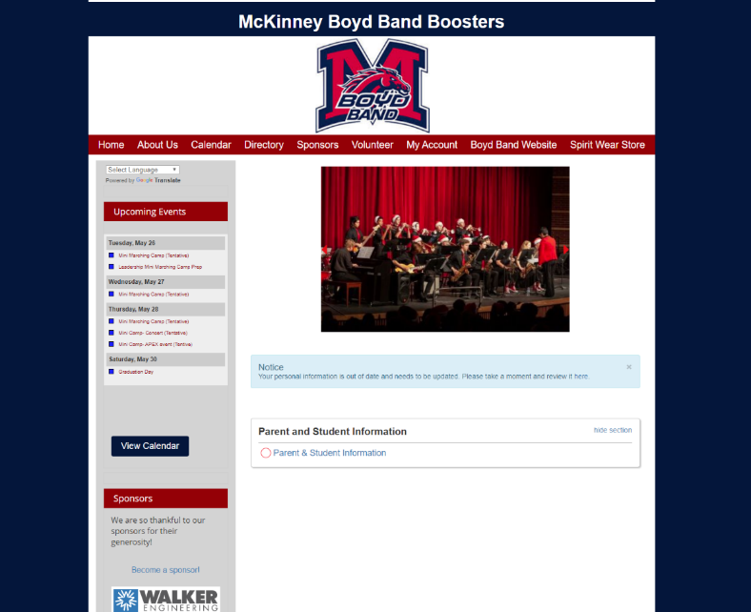
Step 5: Complete Parent and Student Information. After completion, select Next Step at the bottom of screen.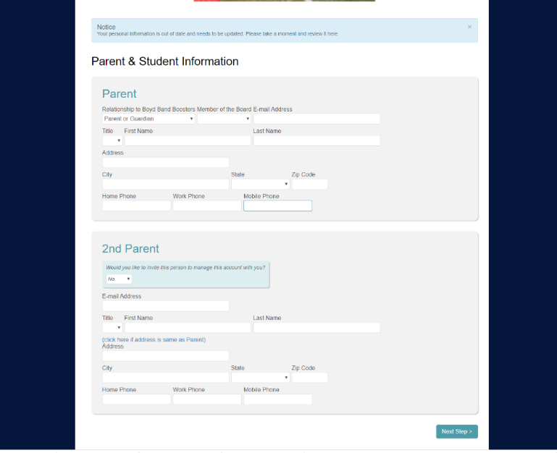
Step 6: Complete Student Information. If you have more than one student, you may add another student by selecting “I have another student.” Don’t forget to Save at the bottom of the page
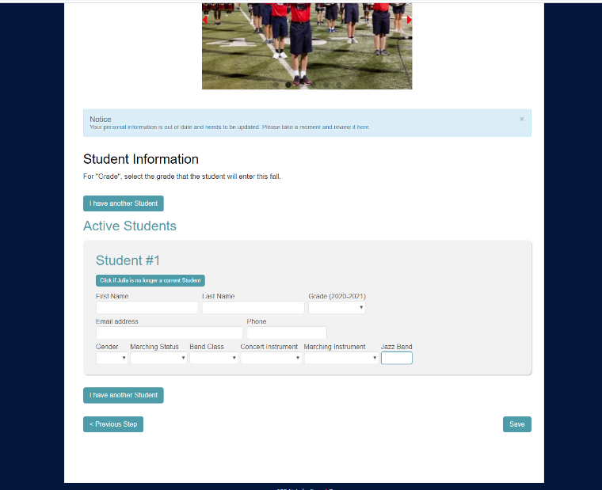
Step 7: Directory & Publishing Preference. Please select the information you do or do not want published in the band directory. Published information will have checks by the information. To unpublish, click the box next to the item you do not want published to remove the check mark. Don’t forget to save at the bottom right.
Step 8: Documentation for your band student
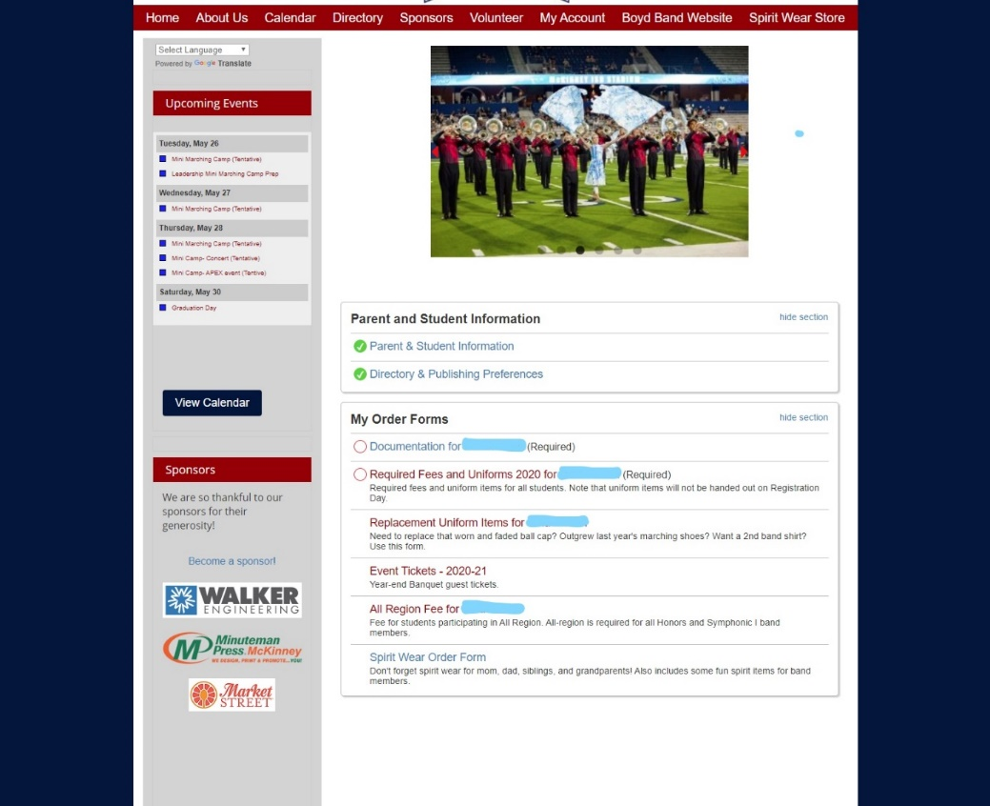
This form has 4 items that need to be completed. The first two are Google forms. The first Google form will have the band handbook, UIL marching rules, and many other items. Complete this 11 page form and return to Membership Toolkit.
All band students will need to submit a physician completed physical form to Mr. Cook at bcook@mckinneyisd.net. You can download the “Blank Physical Form”.
Complete the Private Lessons form even if your student is not currently taking private lessons.
Complete the Contact Permission Section.
If you have successfully completed the 3 google forms, you will receive a confirmation email from either Mr. Cook or Ms. Santamaria.
All Google forms will take you out of Membership Toolkit. Once finished you will need to return to Membership Toolkit and go to My Account on the home page. You should still be logged on. Then select My Account/Forms and Documents.
At the bottom of the page you will notice two messages. If you select the I’m finished and am ready to submit, please make sure you have completed the google forms. If you select that choice and have not completed the forms, you will no longer have access to the documents.
When complete, save and continue.
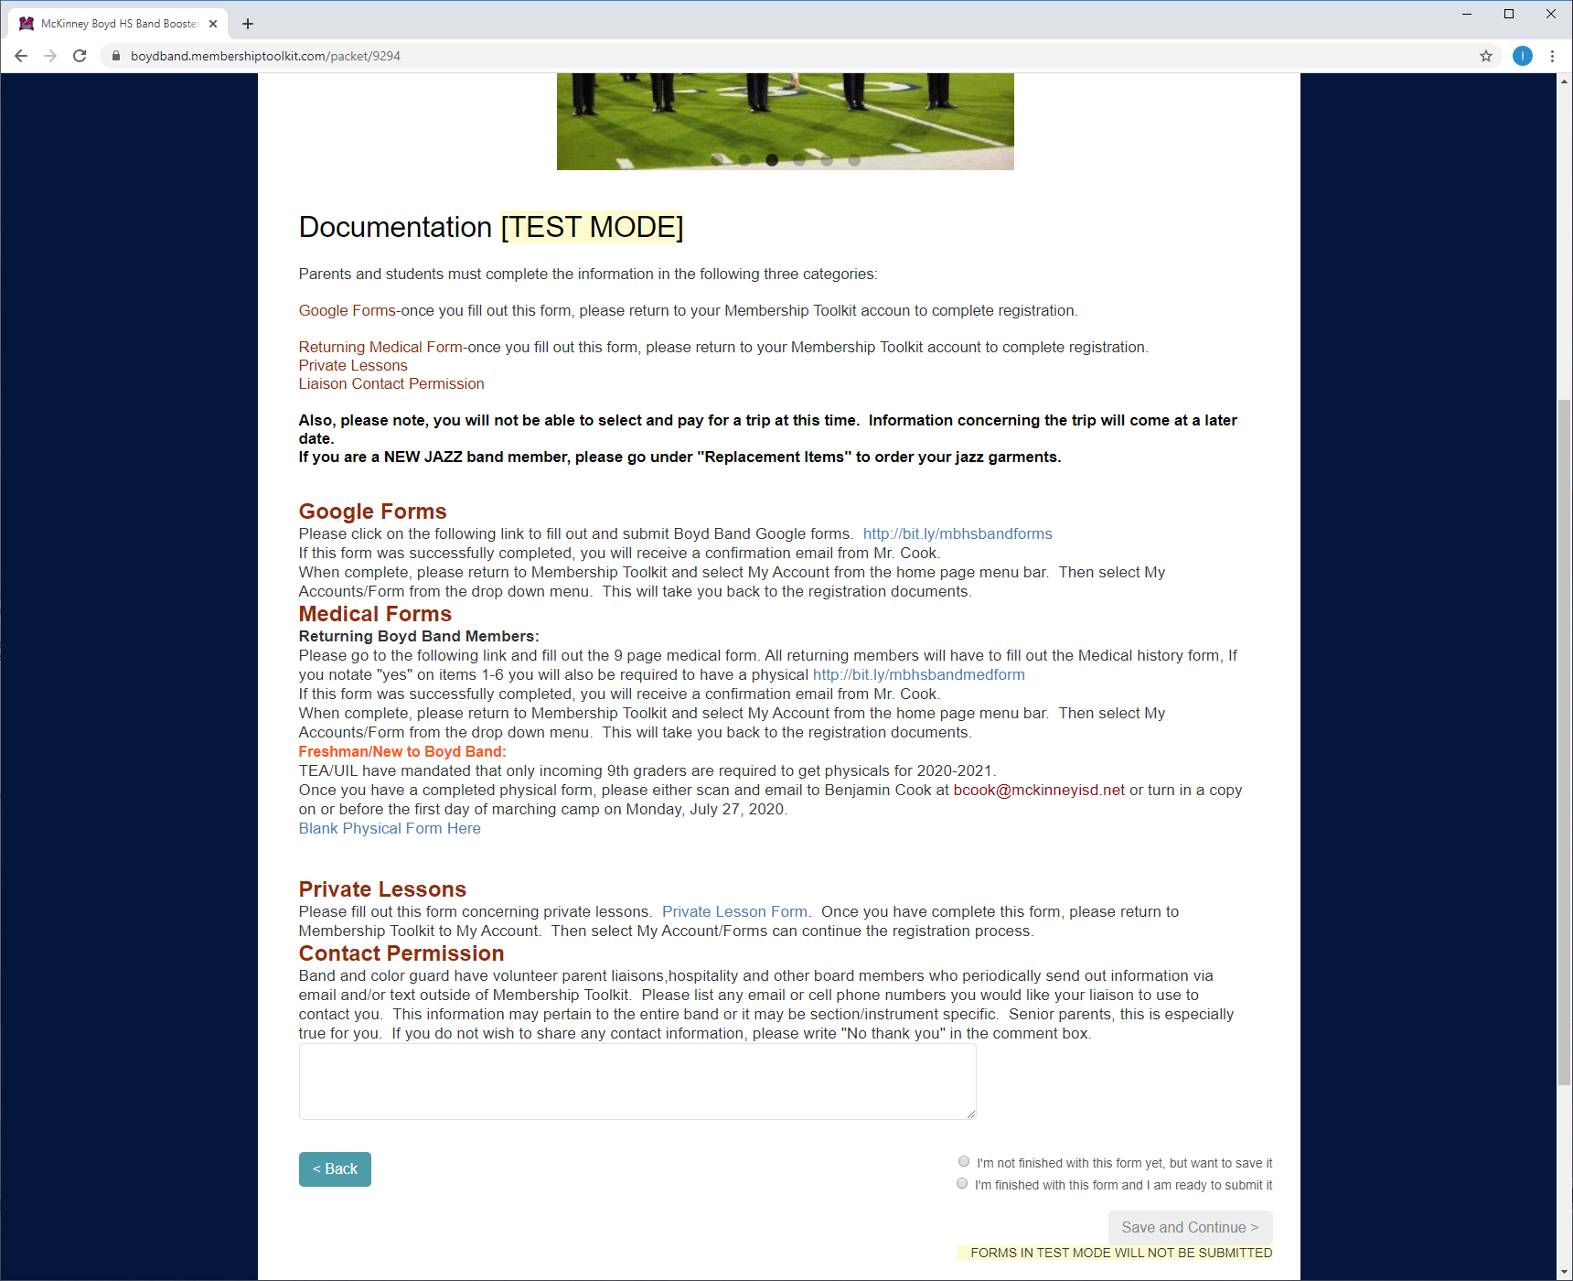

Step 9: Required Fees and Uniform
When selected a few choices will come up. If your student is a freshman, you will only see a few options. If your student is in 10th grade or higher, you will see more options.
If your student is a freshman boy in percussion, select Required items for new Band Boys(Percussion Only). If your student is a freshman in color guard, select Required Items for New Color Guard Members. All other instatements like clarinets, trumpets, trombones, French horns, etc select Required Items for New Band Girls or Band Boys. You will notice BAND boy prices are slightly higher. Band Boy fees include a tux shirt for concert season.
New Jazz Member parents. If your student is new to Jazz band, you will select the Required Items New Jazz Boy or Girl in addition to your regular Required Fees for band, percussion or color guard.
Please note: The uniform coordinator will order the sizes on every item. You will not be able to select a size.
Returning band members will select one that says Required Items for Returning members.
Don’t forget to add it to the cart at the bottom of the page.
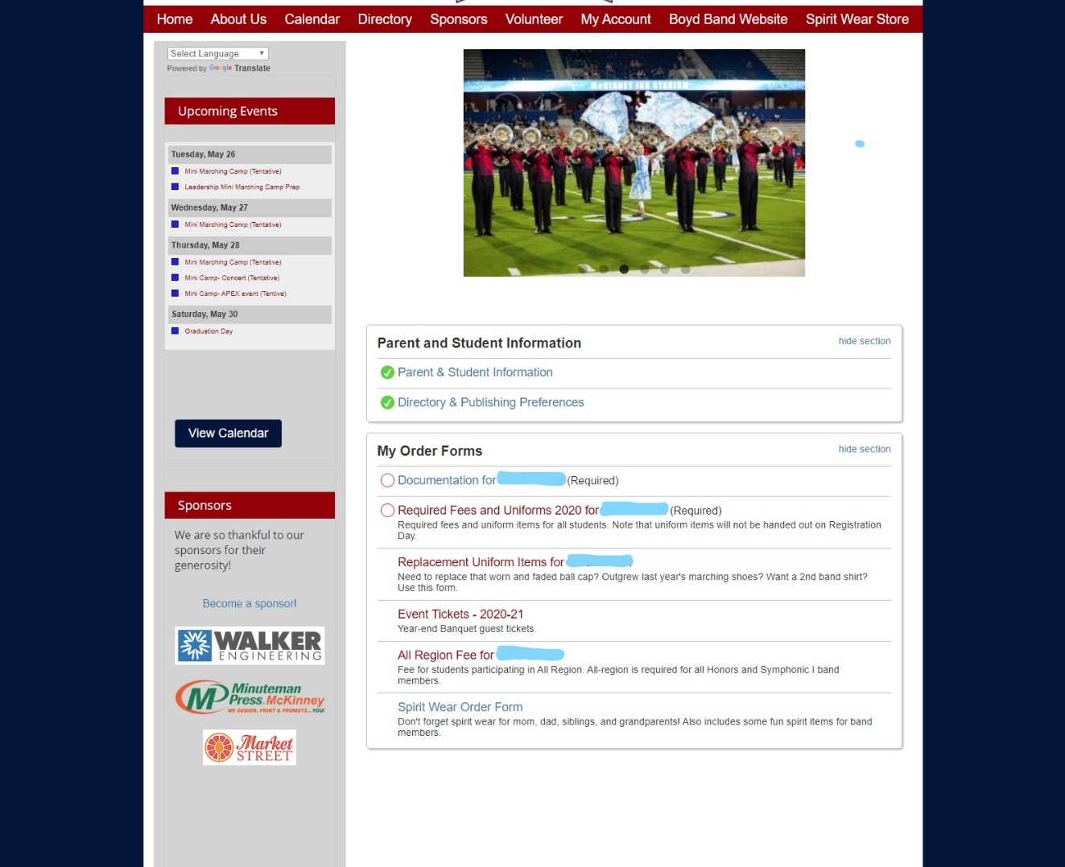

Step 10: All Region Fee/Freshman All Region Fee
Freshman All Region is optional, but freshman band members in Honors and Symphonic 1 can choose to do just Freshman All Region, just upperclassman All Region or both. Upperclassman All Region is mandatory for Honors band and Symphonic I band members. It is optional for Symphonic II and Concert Band. Please note, this event is usually in December. You have plenty of time to return to MTK and pay for this another time. If you want to purchase it now, select the quantity and add it in your cart. Don’t forget to add it to the cart at the bottom of the page.

Step 11: Replacement Uniform Items
The majority of freshman can skip this form. Upper classmen will have options to purchase any item they feel they need to replace. You will not be able to select a size. The uniform coordinator will select the size for the student based off of measurements. Don’t forget to add it to the cart at the bottom of the page.

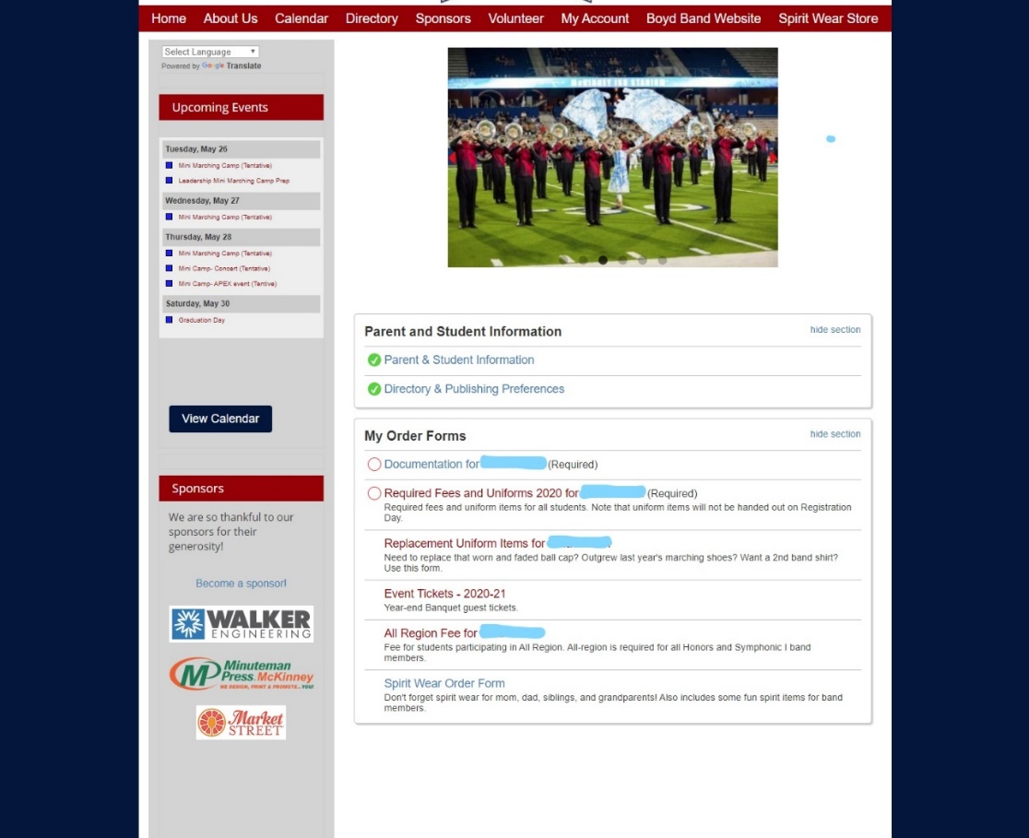
Step 12: Event Tickets
Here you will find tickets for family night in held in the fall and the band banquet held in May. This form to purchase tickets will be available for up to 10 days prior to the event. In other words, you do not have to purchase tickets at this time. You may return prior to the event and purchase tickets. Your band student’s tickets are included in their band fees. You only need to purchase tickets for the rest of the family. If you want to purchase it now, select the quantity and add it in your cart at the bottom of the page.
Step 13: Spirit Wear Order Form
All of this is optional. If you want a band baseball cap or band dri fit shirt for you (not your band student), these items are at a reduced price. The price will go up on the first day of school. Also-cold weather gear. Sometimes it gets cold during the last couple of football games. The band students are only allowed to wear certain items of clothing over their band uniforms. You will see a few listed here. Boyd letterman jackets may also be worn, but band booster does not sell those. Also note, this form will be accessible throughout the year for purchase at any time. Don’t forget to add it to the cart at the bottom of the page.
Step 14: Check out
Once you have looked at all of the forms, please select proceed to checkout. The minimum payment for band fees is $175, but if you have ordered any tickets, all region, replacement items or spirit wear items, those must be paid in full at the time of purchase. Therefore, you must pay total will be higher.
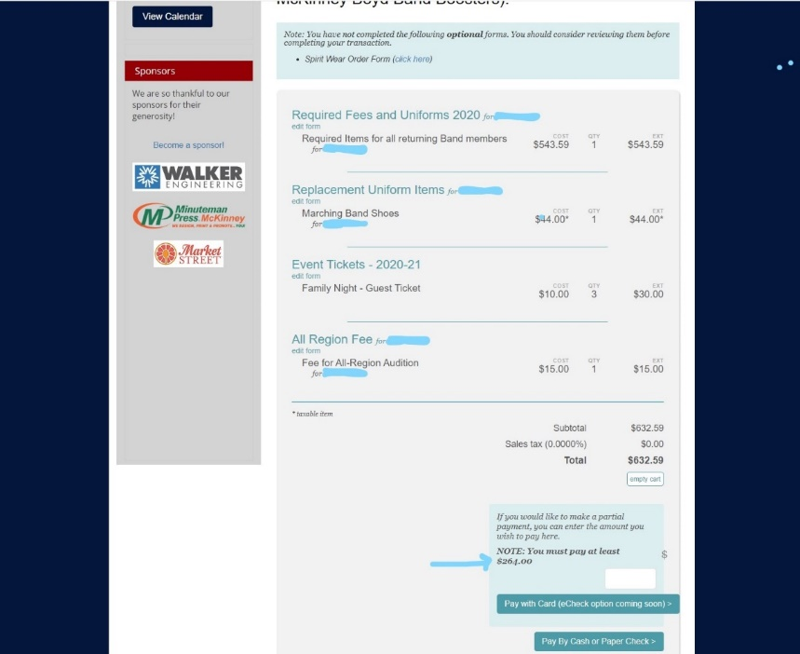
Step 15: Process payment
You will now need to select Place Order for your order to go though. You will receive a confirmation email.
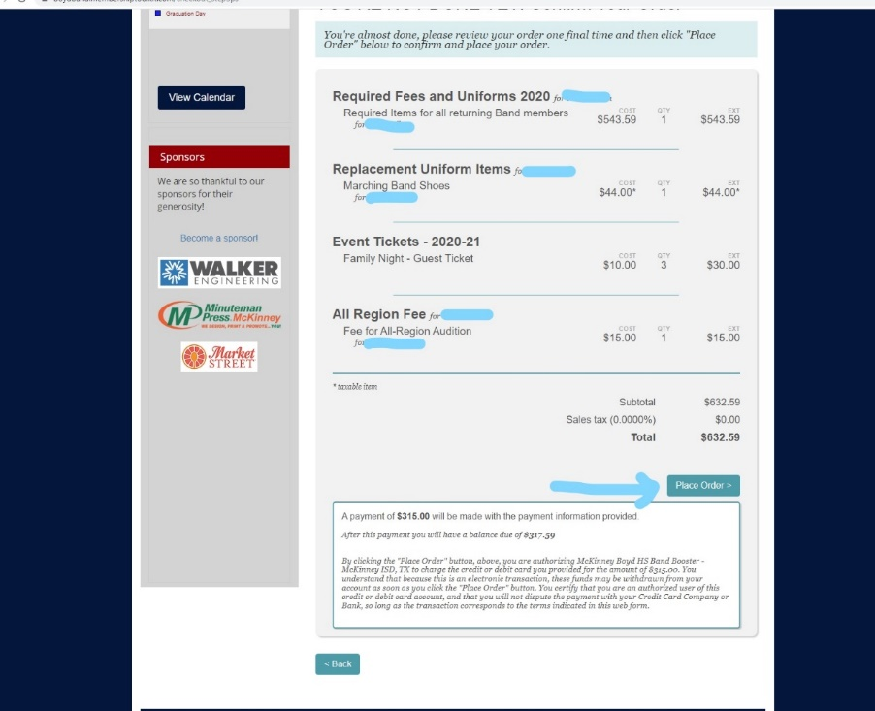
If you return to the home page you can check a few things. If you hover over My Account in the menu bar, you can go to your forms (replacement items, tickets, all region, etc). Here you can find your previous purchases. Previous purchases will give a list of your previous orders where you can find details about your previous orders.
You can also go to the spirit wear store straight from the menu bar.

